11/25/2017



**Design Document**

**Safe and Independent living for elderly people. (Ambient Assisted Living)**

**Student Name: Frank Rooney**

**Student ID: C00196890**

**Supervisor: Hisain​ ​Elshaafi**

Table of Contents

Introduction 2

Architecture 2

Use Case Diagram 3

Detailed Use Cases 4

Login User 4

Inset data 5

View results 6

Print results 7

Registration 8

Log in Admin 9

Play Activity 10

Log out 11

Log out Admin 12

Administration 13

Screens 14

L0GIN 14

Activity Layout 15

WEB APP SCREEN 16

# Introduction

This Design Document will outline the overall design choices for the project. The project is a web application structure to run on any device be it desktop, tablet or mobile. The choice to run on all devices is crucial to its design because of its target market.

The target market is the elderly who suffer from the progressive disease of Alzheimer’s or dementia. There is also the administrative side of the carer or family member. So, the tablet will cater for the elderly with large print and large buttons etc. and the desktop and mobile will accommodate the admin user to allow for easy access from other devices which may be at work or home. The web application will be an interactive game for the tech savvy and non-tech savvy user.

It will be created in Django (Python) and Bulma (CSS) framework with a SQL Server database backend because it will be storing structured data. Django is a well-documented web app framework which allows for SQL injection for smooth transactions. The hosting will probably be PythonAnywhere but that must be confirmed. Other options like AWS (Amazon Web Service) are also in consideration.

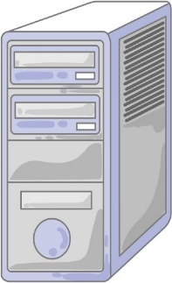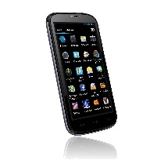

User

Admin Users

Carer/ Family

Database

Web Server

# Architecture

# Use Case Diagram

Actors: Carer, Family Member, Elderly User, API, Database

For the brief use cases Family member and carer will be denoted as Admin.

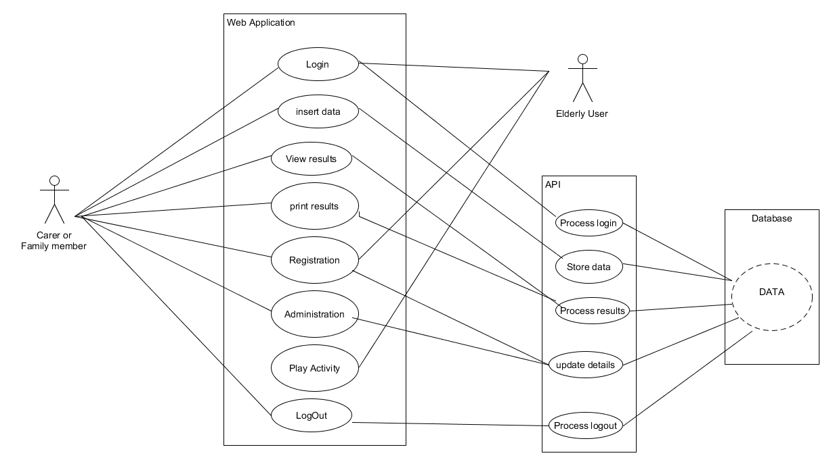

# Detailed Use Cases

## Login User

|  |  |
| --- | --- |
| Name | Login User |
| Actors | User, Web app, API |
| Summary | User wishes to use the application |
| Description | This case begins when a user requires access to the System. The User will receive a request from the server to fill in the username and password. For ease of use there will be a remember me cookie to allow for better user experience. The server will then validate the request with the data base. The case will end when the validation is successful, and the user has logged on. |
| Result | User has successfully logged in |

Main Success Scenario:  
1. This use case begins when a user wishes to log on to the system  
2. The user will search for domain name and home screen will displayed

(This is for first time use after which there will an icon or remember me used to future access system)  
3. The user will receive request from server to fill in username and password on the screen.  
4. The user enters username and password and press confirm.  
5. The System sends the data to the server to be checked against the database  
6. The system validates the user and logs them into the system  
  
Alternatives:  
4a. The user has entered an incorrect username or password.  
5a1. The system informs the user their username and password are incorrect by displaying a message.  
5a2. The User re-enters the correct username and password then clicks confirm.  
5a3. The system goes back to 5 to validate the User

## Inset data

|  |  |
| --- | --- |
| Name | Insert Data |
| Actors | Admin, Web App, API, Database |
| Summary | Admin wishes to upload data to database |
| Description | The Administrator is already logged in. They will be presented a list of Admin functions. From list select insert data. Firstly, a connection must be made to the database. An insert prompt will display a message with an option to insert images or text. Once an option is selected it will now allow user to upload images followed by questions and answers. Execute the insert command and insert to database. Success message then displayed |
| Result | The items have been inserted to database successfully |

Main Success Scenario:  
1. This use case begins when a user wishes to add data on to the system (Assumption: user already logged in)  
2. The system will present the Admin user with a list of admin features.  
3. The Admin user will select from the list   
4. The system will verify request and return an upload data facility.  
5. The Admin user will then click on search for data select file and upload data  
6. The system validates the upload and returns success message.  
  
Alternatives:  
3a. The user has not selected file   
5a1. The system informs the Admin user that no file has been selected by displaying a message.  
5a2. The Admin user selects new file and uploads data  
5a3. The system goes back to 6 to validate the upload

## View results

|  |  |
| --- | --- |
| Name | View Results |
| Actors | Admin, Web App, API, Database |
| Summary | Admin wish to view progress results of user |
| Description | The Administrator is already logged in. They will be presented a list of Admin functions. From list select view results. A further list will be displayed on screen which will allow the admin user to select different results types by filling in some data range fields and press view. The selected results will now be displayed on screen. |
| Result | Required results are displayed correctly on screen |

Main Success Scenario:  
1. This use case begins when a user wishes to view data on to the system (Assumption: user already logged in)  
2. The system will present the Admin user with a list of admin features.  
3. The Admin user will select from the list   
4. The system will verify request and returns a date range pop up box  
5. The Admin user will then fill in date range and press enter   
6. The system validates the date range in database and returns results  
  
Alternatives:  
4a. The user enters wrong date   
5a1. The system informs the Admin user that an incorrect date has been entered by displaying a message.  
5a2. The Admin user enters correct dates  
5a3. The system goes back to 6 to validate the range

## Print results

|  |  |
| --- | --- |
| Name | Print Results |
| Actors | Admin, Web App, API, Database |
| Summary | Admin wish to print progress results of user |
| Description | The Administrator is already logged in. They will be presented a list of Admin functions. From list select view results. A further list will be displayed on screen which will allow the admin user to select different results types by filling in some data range fields and press the print option. The selected results will now be printed. |
| Result | Required results have printed successfully |

Main Success Scenario:  
1. This use case begins when a user wishes to print results from the system (Assumption: user already logged in)  
2. The system will present the Admin user with a list of admin features.  
3. The Admin user will select from the list   
4. The system will verify request and returns a date range pop up box  
5. The Admin user will then fill in date range and enter   
6. The system validates the date range in database and returns results

7. The Admin user selects print

8 The system connects to printer and prints results  
  
Alternatives:  
4a. The user enters wrong date   
5a1. The system informs the Admin user that an incorrect date has been entered by displaying a message.  
5a2. The Admin user enters correct dates  
5a3. The system goes back to 6 to validate and return results

7a. The system cannot connect to printer.  
7a1. The system returns error message  
7a2. The system goes back to 2

|  |  |
| --- | --- |
| Name | Registration |
| Actors | Admin User, User Web app, API, Database |
| Summary | Create a user |
| Description | Any user wishing to the app must find domain name and a landing page will be displayed with a list of options. Login or create account. If registering new account, the user will be presented with a form to fill in the details of Name, address, email etc. Then they must fill in password and confirm. His or her information is now stored in database. A request to login is now displayed on screen. Once filled in and login button pressed. The credentials are validated against the database and access is granted |
| Result | User has successfully registered |

## Registration

Main Success Scenario:  
1. This use case begins when a new user wishes to use the web application  
2. The system will display a registration page and prompt the user fill in the details  
3. The user fills in the account details and creates a login and password  
4. The data is sent to the server for account creation.  
5. The server validates all required fields are filled in correctly.  
6. The server sets up the details on the database  
7. The server informs the user the registration of the details and displays a message your registration has been successful  
8. The system informs the customer they must log in with their details to continue  
9. The system displays the login page  
  
Alternatives:  
4a. The user has entered data incorrectly.  
5a1. The system informs the user the data is incorrect by displaying a message.  
5a2. The user re-enters their details and confirms.  
5a3. The system goes back to 5 to validate the staff ID  
  
6a. The server does not respond  
6a1. The system in forms the user the server is not responding  
6a2. The system stores the information and will email the user with details when a new connection is made.  
6a3. The system returns to 5.

## Log in Admin

|  |  |
| --- | --- |
| Name | Log in Admin |
| Actors | Admin, Web app, API, Database |
| Summary | Admin User wishes to use the application |
| Description | This case begins when a admin user requires access to the System. The system will receive a request from the server to fill in the username and password. For security reasons Admin users will not have a remember me cookie and must login with username and password always. The server will then validate the request with the data base. The case will end when the validation is successful, and the Admin user has logged on. |
| Result | Admin User has successfully logged in |

Main Success Scenario:  
1. This use case begins when a he/she wishes to log on to the system  
2. The Admin user will search for domain name and home screen will displayed

3. The Admin user will receive request from server to fill in username and password on the screen.  
4. The Admin user enters username and password and press confirm.  
5. The System sends the data to the server to be checked against the database  
6. The system validates the Admin user and logs them into the system  
  
Alternatives:  
4a. The Admin user has entered an incorrect username or password.  
5a1. The system informs the Admin user their username and password are incorrect by displaying a message.  
5a2. The Admin user re-enters the correct username and password then clicks confirm.  
5a3. The system goes back to 5 to validate the User

## Play Activity

|  |  |
| --- | --- |
| Name | Play Activity |
| Actors | User Database web app |
| Summary | User wishes to play activity |
| Description | The User is already logged In. Displayed on the navigation bar of the home screen the will be an activity tab. The user must select this. Once selected the activity will load and two options buttons will be displayed. Start and Quit. They user selects start and the activity begins. |
| Result | The activity has successfully started |

Main Success Scenario:  
1. This use case begins with the user has successfully logged on to the system  
2. The system will display a home screen with options

3. The user will select activity from options  
4. The system loads activity and displays start or quit buttons.  
5. The User selects start button   
6. The system starts activity  
  
Alternatives:  
4a. The user selects quit button   
5a1. The system informs the user “do you want to quit yes/no” by displaying a message.  
5a2. The user selects yes.  
5a3. The system goes back to 2 and displays home screen options

## Log out

|  |  |
| --- | --- |
| Name | Log out |
| Actors | User, Database, web app |
| Summary | The user wishes to log out of the Web Application |
| Description | There is a remember me cookie on registration to make the user experience easier. IF the User wishes to log out of the application. The user must navigate back to home screen there they will find a log out button. The user selects the button. A message box will display a confirmation message (Are you sure you want to log out Yes/NO the credentials are verified against the database and the session is terminated a valid response is returned |
| Result | The user has successfully logged out |

Main Success Scenario:  
1. This use case begins with the user wishes to log out of system  
2. The system will display a home screen with options

3. The user will select log out from options  
4. The system informs the user do you want to log out” yes/no” by displaying a message.  
5. The user selects yes

6. The system verifies the user and terminates the session

7. The system displays login screen

Alternatives:  
5a1. The user selects No.   
5a2. The system goes back to 2 and displays home screen options

## Log out Admin

|  |  |
| --- | --- |
| Name | Log out Admin |
| Actors | Admin, Database, web app |
| Summary | The Administrator wishes to log out of the Web Application |
| Description | The Administrator wishes to log out of the application. He or she are presented with a tab within the administration home Page. The Administrator selects the admin tab from the Navigation bar and then selects log out tab. A message box will display a confirmation message (Are you sure you want to log out Yes/NO the credentials are verified against the database and the session is terminated a valid response is returned |
| Result | The admin user has successfully logged out |

Main Success Scenario:  
1. This use case begins with the user wishes to log out of system  
2. The system will display a home screen with options

3. The Admin user will select log out from options  
4. The system informs the user do you want to log out” yes/no” by displaying a message.  
5. The Admin user selects yes

6. The system verifies the Admin user and terminates the session

7. The system displays login screen

Alternatives:  
5a1. The Admin user selects No.   
5a2. The system goes back to 2 and displays home screen options

## Administration

|  |  |
| --- | --- |
| Name | Administration |
| Actors | Admin, API, Web app, Database |
| Summary | Admin user wishes to update database |
| Description | The Admin user is already logged in. Displayed on the navigation bar on the admin user home page is the administration tab. when selected this will display a list of option for updating the details of users. Then admin user can update create and delete any detail from here. Once the correct details have been altered the user will be shown and alert box asking to confirm the changes. If confirm the selected details will be updated. |
| Result | Data has been successfully updated |

Main Success Scenario:  
1. This use case begins when a user wishes to update data on to the system (Assumption: user already logged in)  
2. The system will present the Admin user with a list of admin features.  
3. The Admin user will select from the list   
4. The system will verify request and return and display data for update.  
5. The Admin user will then click on the appropriate for data for update   
6. The system validates the update and returns a message to confirm update YES/NO

7. The Admin user will select yes

8. The system will now update and display message update successful  
  
Alternatives:  
5a. The user has not selected file   
5a1. The system informs the Admin user that no file has been updated by displaying a message.  
5a2. The system goes back to 3.

# Screens

## L0GIN

Login

This screen will be presented when select from web application in URL.

The user can login by entering their user name and password. Which are verified against database to allow access. There is also the register for account facility here for new users.

A remember me option also here to avoid constant login.

The background will be customisable once you have registered and are setting up account.

## Activity Layout

This screen shows a typical activity.

From here an image will be displayed with a corresponding question. There are large buttons with a multiple-choice answer. The large button is for ease of use.

There are also large buttons for Next question, Quit or Hint. The hint is to help jog memory and can be prepared when creating question.

The score will be displayed through the quiz.

## WEB APP SCREEN



**REGISTER**

**LOGIN**

**WEEEABOUT**

**WWWW**

**WWWECONTACT**